1. **Principles of public finance law in Victoria**

# **Introduction**

This chapter concerns the fundamentals of public finance, and how they are reflected in Victoria.

The key elements of our system of public finance are these:

* Getting money in;
* Holding and managing public funds;
* Permission to spend;
* Releasing money;
* Responding to changing circumstances;
* Reporting and accountability.

In addition, there is an increasing expectation that public money will be collected and expended according to agreed principles and for well-articulated purposes, and that subsequent reporting and accountability will also have regard to those principles and purposes.

# **Getting money in**

The main sources of revenue for the Victorian Government are:

* Taxes;
* Fees and fines;
* Sales of capital assets;
* Sales of goods and services;
* Dividends and interest; and
* Grants from the Commonwealth.

In the budget for the current year (2025-26), the percentage of revenue from these sources was:

|  |  |
| --- | --- |
|  | % |
| Taxation | 38 |
| Dividends, income tax equivalent revenue, interest | 2 |
| Sales of goods and services | 7 |
| Commonwealth grants | 49 |
| Other | 3 |

*Source: 2025-26 Budget Paper No. 2*

There are important legal requirements in relation to legislation that raises revenue.

* A Bill for imposing any duty, rate, tax, rent, return or impost must originate in the Assembly (*Constitution Act 1975*, s 62(1)).

However, a Bill is not such a Bill if all it does is impose fines or other pecuniary penalties, or has provisions for licence fees or fees for services: *Constitution Act 1975*, s 64(1).

* Such a Bill may be rejected by the Legislative Council, but not amended by it (*Constitution Act 1975*, s 62(2)).
* Therefore, such a Bill must relate only to taxation etc., and not have other laws “tacked” onto it (constitutional convention), which are matters that are unconnected with the granting of supply.

# **Holding and managing public funds**

Once funds have been received, they must be held and managed.

The first requirement is that all taxes, imposts, rates and duties (etc.) shall form one Consolidated Revenue… (*Constitution Act 1975* s 89*)*

Historically this was an important principle because it could otherwise be legal for office holders collecting taxes to collect the whole tax and remit to the government an amount net of their commission. The right principle is that all the tax is paid into the Consolidated Revenue and the tax collector remunerated from moneys appropriate for the purpose.

In modern times it is still an important principle, because the alternative is to place funds received in particular accounts, placing them outside the normal budget and appropriation processes and disciplines.

Under the *Financial Management Act 1994* (**FMA**):

* A person who collects or receives public money must pay the money into the Public Account (s 16);
* The Minister must open and maintain the Public Account with such authorised deposit- taking institution(s) as the Minister determines (s 14); and
* The Minister must ensure that a ledger is established and maintained to record (a) transactions on the Public Account; and (b) expenses and obligations incurred that are to be met out of the Public Account (s 13).

The box below describes how funds are held and managed.

**Trust Fund and Trust Accounts**

The Trust Fund is made up of all the State's trust accounts. Trust accounts are not "trusts" in the legal sense (although they are occasionally used to hold and distribute funds that the State holds on trust for a particular purpose, such as donations from the public to aid victims of a disaster). Rather, they are accounts operating discretely, usually because money has to be received into them, managed while in them, or paid out of them, in particular ways.

They can be set up either by legislation (usually as part of some larger scheme) or by the Assistant Treasurer under the FMA (s 19). They include trust accounts administered jointly by the Commonwealth and the State, or accounts used to hold Commonwealth specific purpose payments.

The Department of Treasury and Finance (**DTF**) must be informed about any proposal to create a trust account, and there are both legislative and policy requirements about managing them, borrowing money from them, and merging and closing them.

The public ledger is an accounting concept. The public ledger includes the Consolidated Fund, which is everything except for what is in the Trust Fund.

The actual funds are held in the Public Account (which is a bank account), or invested through Treasury Corporation Victoria or the Victorian Funds Management Corporation, both of which are statutory authorities. Money can be borrowed through these corporations and paid into the Public Account.

It is really important to note that departments and agencies cannot borrow or invest money unless they are explicitly permitted to do so, in that particular way, by the *Borrowing and Investment Powers Act 1987* (**BIP Act**). It is not uncommon for various boards and committees to decide that they can do better by investing money in a particular way, or that they should put their surplus funds to work in particular ways. Unless they are listed in the Schedules to the BIP Act, that will be contrary to legislation.

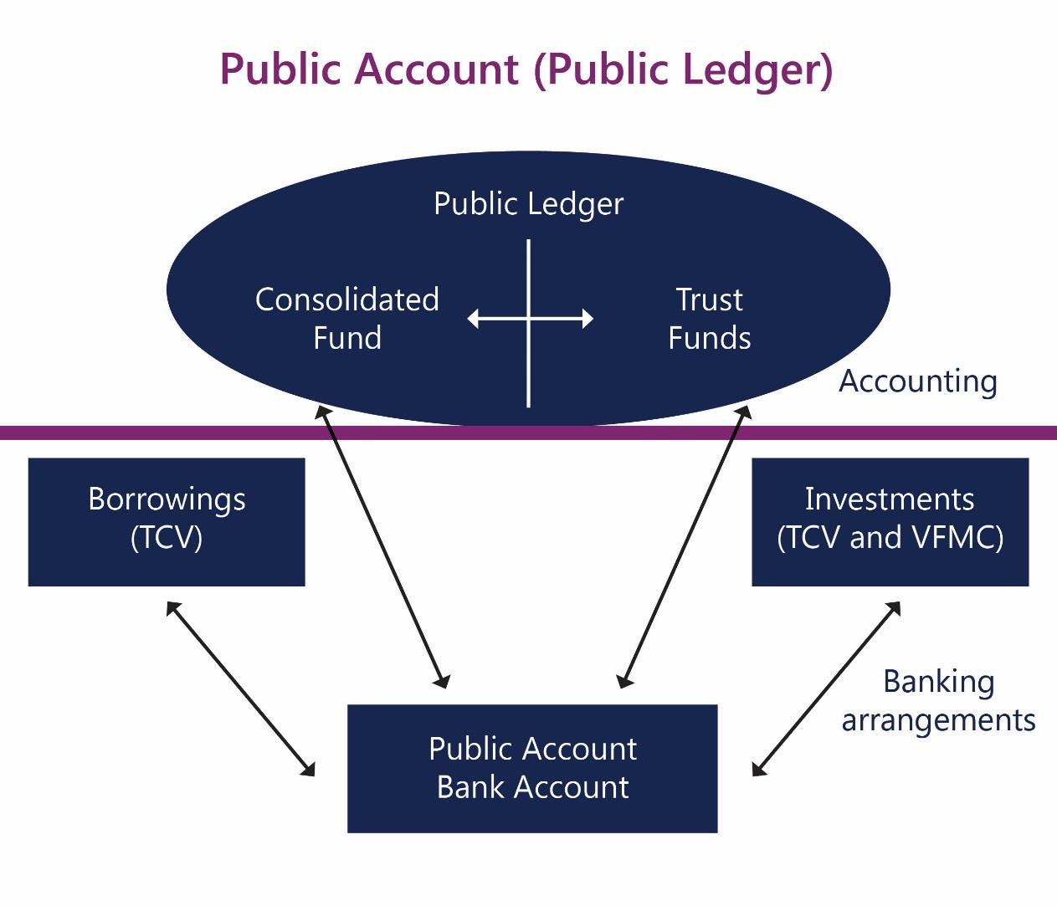

Source: Budget Operations Framework For Victorian Government Departments, updated February 2017, Department of Treasury and Finance

# **Permission to spend**

Money in the Consolidated Revenue cannot be spent without Parliamentary approval.

The Consolidated Revenue …shall be subject to be appropriated to such specific purposes as by any Act shall be provided in that behalf. (*Constitution Act 1975*, s 92)

An appropriation is an authority given by an Act of Parliament to draw certain sums out of the Consolidated Fund, either now or in the future, for the purposes stated and up to the limit (if any) of the amount in that particular Act.

In the same way that there are rules about taxation, there are also rules about appropriation.

* A Bill for appropriating any part of the Consolidated Fund or for imposing any duty, rate, tax, rent, return or impost **must originate in the Assembly**. (*Constitution Act 1975* s 62(1)).
* The Assembly may not pass any vote resolution or Bill for appropriating any part of the Consolidated Fund…which has not been first recommended by a message of the

Governor to the Assembly during the session in which such vote resolution or Bill is passed. (*Constitution Act 1975*, s 63).

The effect of these provisions is not only that every appropriation must be authorised by the Parliament, but also that, practically, the government of the day is responsible for passage of Bills to appropriate funds. (The Governor only acts on the advice of the government, so that the “message” recommending the Bill will only be sent at the behest of the government.)

Section 92 of the Constitution also requires that appropriation be for a “specific purpose”. Practice suggests that this requirement is satisfied if the funds are appropriated for the purpose of the operating expenses and capital expenditure of each department.

There are two forms of appropriation: annual appropriation, and special (or standing) appropriation.

Annual Appropriation

The annual appropriation is part of what is commonly referred to as the annual Budget. There are unique rules relating to the Annual Appropriation Bill in s 65 of the *Constitution Act 1975*.

1. In this section Annual Appropriation Bill means a Bill which deals only with the annual appropriation of the Consolidated Fund for the ordinary annual services of the Government for a particular year only but does not include a Bill to appropriate money for appropriations for or relating to the Parliament.
2. For the purposes of subsection (1), ordinary annual services includes—
   1. the construction or acquisition of public works, land or buildings; and
   2. the construction or acquisition of plant or equipment which normally would be regarded as involving an expenditure of capital; and
   3. services proposed to be provided by the Government which have not formerly been provided by the Government.

An Annual Appropriation Bill requires only passage in the Legislative Assembly and Royal Assent—in other words, it cannot be rejected by the Legislative Council, although the Legislative Council does have one month to consider it and make suggestions to the Assembly.

Each year there is an Appropriation Act for government:68 The key provisions are:

* *Issue of moneys*

"The Treasurer may issue out of the Consolidated Fund in respect of the financial year 2025/2026 the sum of $99 787 859 000 as set out in Schedule 1."

* *Appropriation*

68 There is always a second Appropriation Act, for the Parliament itself.

The Consolidated Fund is appropriated to the extent necessary for the purposes of section 3.

* *Application of amounts appropriated*

The amounts to be applied to an item specified in Schedule 1 shall not, except as provided in this section or s 30 of the FMA, exceed the amount specified for that item.

The Schedule to the Act sets out items of expenditure and the amounts available for each item. In every case, the appropriation is to a department: even if the eventual purpose is to support activities of other agencies or entities, the initial appropriation will be to a department.

Every departmental appropriation will have two items: for the provision of outputs, and for additions to the net asset base.

Some departmental appropriations may also have items covering payments made on behalf of the State, and payments required under specified Acts or agreements.

The appropriation to DTF includes an amount available to the Treasurer for Treasurer's advances, to be retrospectively authorised in a later Act.

The item that government lawyers are most likely to need to know about is the “provision of outputs”. All that you will see in the Appropriation Act is a single figure for the Department. The actual outputs, and the amount appropriated for any given output, are normally in

Budget Paper 3 in the budget papers associated with that year’s budget. These are available on the DTF website.

## Special appropriations

Special appropriations are used for ongoing payments that need to be made independently of the Government’s annual budget priorities. Special appropriations represent a standing authority and do not lapse each year as annual appropriations do, but remain in force until amended or repealed by Parliament.

It is common to find on the statute book Parliamentary approval to expend funds in

particular circumstances as and when they arise, with a formula along the lines of “…and the Consolidated Fund is to the necessary extent hereby appropriated accordingly.”

Some examples of special appropriations are these:

* *Constitution Act 1975,* s 7(2)

The salary (including the amount of any non-salary benefits) of the Governor shall be paid out of the Consolidated Fund which is hereby to the necessary extent appropriated accordingly.

* *Constitution Act 1975* s 90

The Consolidated Revenue shall be permanently charged with all the costs charges and expenses incidental to the collection management and receipt thereof such costs charges and expenses being subject nevertheless to be reviewed and audited in such manner as shall be directed by any Act of the Parliament.

* *Crown Proceedings Act 1958* s 26

(1)…[A]fter any judgment order or decree has been given pronounced or entered against the Crown in any such proceeding the proper officer of the court shall give to the party in whose favour it was so given pronounced or entered a certificate setting out the sum awarded against the Crown in the proceeding...

On the receipt of such certificate it shall be lawful for the Governor to cause to be paid out of the Consolidated Fund (which is hereby to the necessary extent appropriated accordingly) the sum set out in the certificate and also to cause compliance to be made with the other particulars set out therein.

Special appropriations are most commonly found in these situations:

* where it is important for the institutions of the State that there be no doubt that money will be available to support the institution (e.g., the salaries of the Governor and judges);
* where it cannot be known if and when money will have to be paid, but when those circumstances arise there must be no doubt that it is available; and
* where it is a necessary and incontestable part of some scheme that funds be available in order to fulfil its purposes (e.g., various aged, disability and retirement pensions, noting these are more relevant at the Commonwealth than a State level).

# **Releasing money**

## Releasing money to the government

Victoria has additional legal requirements relating to the process by which money appropriated by the Parliament can be drawn from the Public Account, which are called warrants. Warrants are the legal instrument required to draw down actual funds from the Consolidated Fund. Each year’s Appropriation Act requires a warrant to be prepared and authorised before funds can legally be drawn down from the Consolidated Fund. : see s 93 of the *Constitution Act 1975* and s 17 of the FMA.

## Releasing money to departments

Money is available to the government as a whole, and is centrally managed by the Treasurer until it is released to departments. For accounting and conceptual purposes the funds are held by a notional entity called the 'State Administration Unit (**SAU**)'. The SAU serves as:

* an accounting mechanism for capturing and recording transaction flows and balances in the Public Account; and
* a means of capturing certain relationships and balances between the Government (with DTF as the ‘corporate head office’) and departments from an accounting and reporting perspective. Note the SAU is not a separate legal entity in its own right.

## Payments by departments

There are no provisions in the FMA specifically relating to payments by departments, but there are specific provisions regarding things like asset registers and risk management strategies (s 44B), writing off (s 55), recovery of overpayments (s 56) and how departments manage and use funds.

It is most important that government lawyers in any way providing advice in relation to general public administration be familiar with the *Standing Directions 2018* under the FMA (**Standing Directions**). These are made under s 8 of the FMA, which provides that the Minister may give a direction to an accountable officer or CFO regarding any matter regarding which regulations may be made.

The directions are structured at three levels: the directions themselves (which are mandatory), instructions in relation to the directions (also mandatory) and guidelines (not mandatory).

The key topics covered by the directions include requirements relating to:

* financial management governance;
* internal controls;
* Audit Committees;
* internal audit;
* reporting; and
* compliance.

Government lawyers should be aware especially that the rules operating within government in relation to financial authorisations, fraud, credit cards and discretionary financial benefits are to be found in the Standing Directions.

The Directions also mandate the government policy frameworks, which include the Asset Management Accountability Framework, and in many cases all the Standing Directions require, is compliance with some other policy.

Purchasing by government departments (and some, but not most statutory authorities) is regulated by supply policies, which are made by the Victorian Government Purchasing Board under s 54L(1) of the FMA.

# **Responding to changing circumstances**

For the sake of completeness it should be mentioned that there are numerous provisions that allow the government to respond to changing circumstances, and to achieve flexibility across financial years even though appropriation is only for one financial year.

The provisions and how they are applied are to a considerable extent an attempt to reconcile the accrual accounting by which the State's finances are managed with the cash accounting on which annual appropriation is premised.

At present these legislative provisions fall into two categories:

## Moving funds between financial years:

* borrowing against future appropriation (FMA s 28)
* carryovers of unused prior years appropriations (FMA s 32)
* access to balances in a Department’s State Administration Unit inter-entity account (which may comprise accumulated surpluses, or appropriation provided in prior years for specific accrued liabilities such as long service leave or accumulated depreciation equivalent) (FMA s 33)

## Obtaining additional funds:

* Treasurer’s Advance for urgent and unforeseen claims (Appropriation Act);
* Additional payments in order to satisfy the new awards for salaries and related costs (Appropriation Act s 3(2))
* Temporary Advance (FMA s 35)
* Public Account advance (FMA s 37)

# **Reporting and accountability**

An important part of the system of public finance relates to reporting and accountability, not least because the cycle of budgeting and reporting affects the rhythm of departmental priorities and preoccupations.

At a whole of government level there is the annual Budget, and reports produced quarterly and tabled in Parliament, the annual financial report, the half yearly report, and then quarterly reports in between. All of these are described in Part 5, Division 5 (Disclosure of financial results) of the FMA.

Once every four years is the Pre-Election Budget Update, which is produced by the Secretary of DTF independently of the Treasurer.

At a departmental (and agency) level there is tabled in Parliament an annual report of operations and financial statements. The financial statements are audited by the Auditor-

General. The overall requirement is in s 45 of the FMA, with detailed requirements in the Financial Reporting Directions.

Two important institutions are the Auditor General (who is an officer of the Parliament under s 94A of the *Constitution Act 1975*) and the Public Accounts and Estimates Committee (**PAEC**), which is one of the Parliamentary Committees.

* + 1. The functions of the Public Accounts and Estimates Committee are—
       1. to report to the Parliament on—
          1. any proposal, matter or thing concerned with public administration or public sector finances;
          2. the annual estimates or receipts and payments and other Budget papers and any supplementary estimates of receipts or payments presented to the Assembly and the Council;
          3. audit priorities for the purposes of the *Audit Act 1994*;

(*Parliamentary Committees Act 2013*, s 14)

In practice the PAEC undertakes two major reports:

* Report on budget estimates (that is, report on the annual budget); and
* Report on Financial and Performance Outcomes (effectively, report on annual financial statements of government and departments).

The report on the budget estimates continues to be annual, but in recent years the PAEC has issued a combined report for two consecutive financial years.

As well as interrogating the plans and activities of departments, the PAEC also looks carefully at issues of public sector accounting and transparency.

The appearance of Ministers and Secretaries before the PAEC in relation to budget estimates and Financial and Performance Outcomes are important and sensitive events in the annual cycle of each department.

# **Conclusion**

While public finance is inherently interesting, and at the heart of government, there are some particular aspects of it of particular concern to government lawyers. They are:

* There is an important and ongoing dynamic between the government and the Parliament about how money is raised and spent, and some long-standing constitutional rules and conventions about the relationship between the government and the Parliament;
* Numerous matters, including borrowing and investment, the sources of funds, contracting, financial delegations and how money can be moved (or not moved) across financial years and between departments, are subject to complex and very specific rules;
* There is a demanding process of reporting and accountability, with the Public Accounts and Estimates Committee playing a particular role in considering the budgets and annual reports of departments.